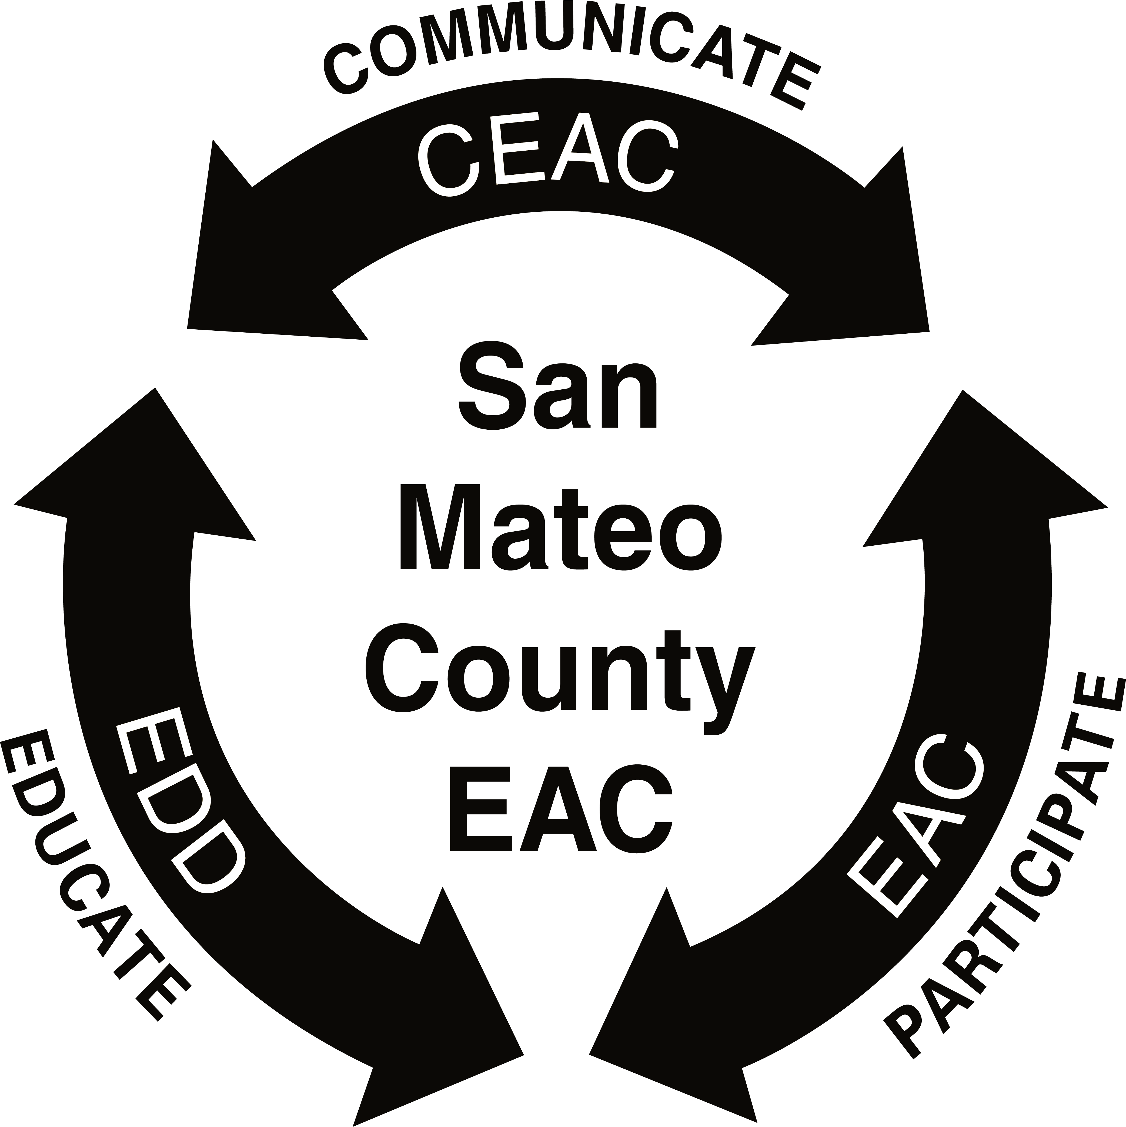
The San Mateo County Employer Advisory Council and the Employment Development Department Announce:

Scholarship Available For 2021

Purpose of Scholarship: To assist San Mateo County students who are studying Business Administration, Human Resources, or other areas of study that will ultimately provide the opportunity to make a contribution to our society. Scholarship awards are used to further the education of recipients.
About the Employer Advisory Councils (EAC’s): Formed in 1978 to serve in an advisory capacity to the Employment Development Department (EDD) Workforce Services Program. The San Mateo County EAC meets monthly to exchange information, ideas, and concerns about Human Resources management issues.
Required for Application:
- Brief letter of introduction (approximately 300-500 words) stating your financial needs as well as career and personal goals. Your letter should demonstrate why you should be awarded this scholarship. Include your mailing address, telephone number where you can be reached, and your email address.
- One letter of recommendation from a school counselor or teacher, community agency, employer, or other professional entity familiar with your qualifications
- History of academic accomplishments, volunteer services, certificates of achievements, etc., demonstrating a desire to learn
- Personal interview with the EAC Scholarship Committee
- Scholarship recipient(s) must be present at the Awards Ceremony, Wednesday, August 25, 2021.

Eligibility for Scholarships: Any undergraduate student residing in San Mateo County, enrolled or planning to enroll in: Community College, College or University, Vocational Training Program, or Adult School R.O.P. Previous San Mateo County EAC Scholarship recipients are not eligible.
Award Amount: $1,000.00
Application Schedule:
Applications must be postmarked, or emailed, no later than Wednesday, June 23, 2021.
Finalists will be interviewed on Friday, July 2, 2021.
Recipients will be notified no later than Friday, July 9, 2021.
Awards ceremony will be held on Wednesday, August 25, 2021.

Mail Application to: or Email Application to:
EAC Scholarship Committee sanmateo.eac@gmail.com
P.O. Box 5633
South San Francisco, CA 94080

